**Lab 03: Introduction to RStudio and Basic Manipulations**

1. Access R Studio Cloud
2. R verses Python Debate
3. R Studio Desktop Installation
4. The R Studio Interface
5. R Data types
   1. Character
   2. Numeric
   3. Logical
6. Vectors In R
7. R Functions



1. Write a program to find minimum and maximum of number series in R.

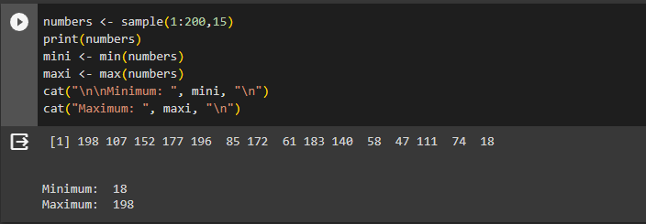

1. Write a program to test whether the value of the element of a given vector greater than 10 or not. Return Statement in Logical (TRUE or FALSE)

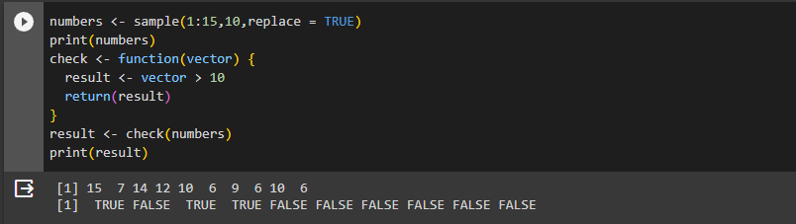

1. Find Sum, Mean and Product of Vector in R Programming.

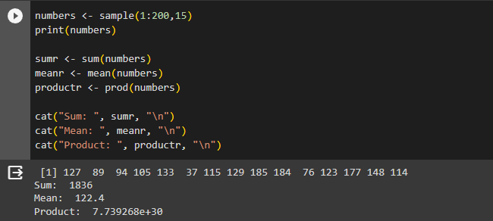

1. Write a program to find common elements from multiple vectors.

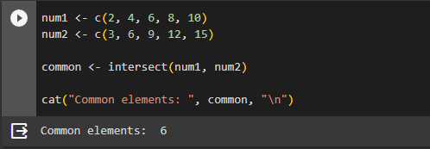

1. Write a program to create three vectors numeric data, character data and logical data. Display the content of the vectors and their type.

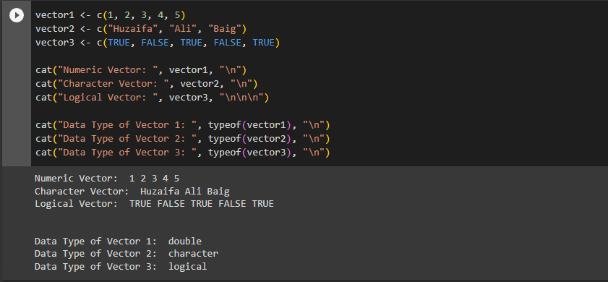

1. Write a program to create a vector of a specified type and length. Create vector of numeric, complex, logical and character types of length 6.

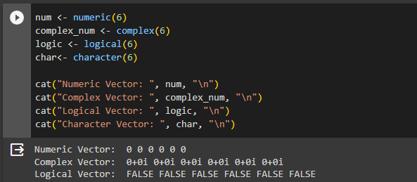

1. Write a program to read the .csv file and display the content.

